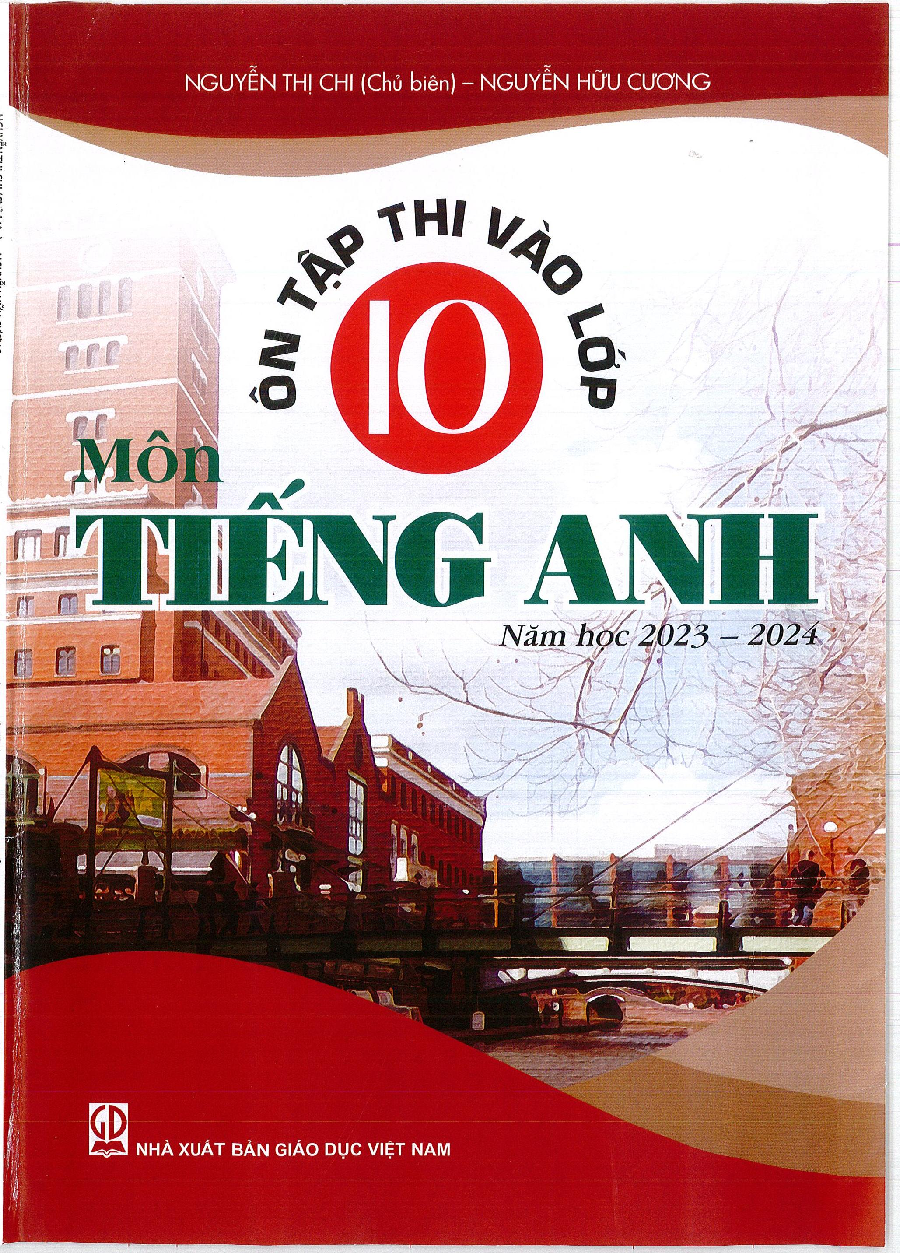

NGUqN THI CHI (Cht) bi6n) — NGUY6N HOU CLYONG

**NHA XUAT BAN GIAO DUC VIET NAM**

NGUYEN THI CHI (Ch6 bi6n) - NGUYN HOIJ CUZING

NHA XUAT BAN GIAO DUC VICT NAM

**6N TAF' THI VA0 LdP 10**

**1$116N TliNG ANH**

**NAm hoc 2023 - 2024**